BME 7310 Midterm Exam

Fall 2023

Due: 60 hours from when you start, October 16, 2023 (last submission, 6pm)

Instructions: All work must be done **individually** (absolutely no collaborations!). “Open material” includes course textbooks (Lynch, Burden, or Schey) **only,** class notes and videos, previous laboratory assignments, and the computer as far as software you developed is concerned – no internet (alternate software can only be used for visualization: i.e. **do not use other software packages to confirm your results which includes symbolic packages)**. You must create and use your own software (you may use programs that you have written from earlier assignments). **You must turn in copies of the programs (m-files) you use along with the appropriate paperwork to document what each program is attempting to accomplish.**  No late submissions will be accepted. Also, I want a clear progression in your work. ***I would like the work neat and orderly….***

In terms of effort, problems 1 should probably take you 5-10 minutes at most. Problem 2 should take you 45-60 minutes. Problem 3 will take you a **considerably longer amount of time, something similar to a regular, challenging modeling homework problem**. Please plan accordingly and allow time for debugging.

GOOD LUCK !!!

BME 7310 Midterm Exam

Honor Policy

“I have neither given nor received unauthorized aid on this mid-term examination. All work is my own, I have not sought out assistance from other participants in this course past or present or outside agents.”

On my honor, I pledge: Nguyen, Tran Tuan Khai

Exams will not be accepted without taking the honor pledge. Date: 10/14/2023

**Problem 1. Error Analysis (10 pts).** You have contracted with ODEWORKS INC. to serve as a “Beta test-site” for some new software which solves first order ODE initial value problems. The company tells you that the software is based on local truncation of the exact expression below where the last term is the leading error term when deriving the approach:

$$y_{i+1}=y_{i}+\frac{h}{12}\left(5f_{i+1}+8f_{i}-f_{i-1}\right)-\frac{1}{24}f'''\left(ξ_{i}\right)h^{4}$$

Where $ξ_{i}∈\left[t_{i-1},t_{i+1}\right]$. You have run the software on a test problem with a known analytic integration solution and have plotted on a log-log scale the **error** between the exact and numerical solutions at a fixed point in time, To as a function **of N where h= To /N**. The results you produced are shown below. Is the relationship you generated below consistent with the information the company supplied to you about the method above? Why or why not?





**Answer:**

From the equation: Since *Error = $\frac{1}{24}f'''\left(ξ_{i}\right)h^{4}$* , on a loglog plot of Error versus N, or equivalently 1/h , we

should see a constant linear negative slope of -4 that reflects the order of the truncation error term.

In the plot: from the 2 red points marked on the graph, the slope is $\frac{\left( log\left({10}^{-2}\right)- log\left(6.3\right)\right)}{log⁡(10)-log⁡(2)}≈-4.004$ close to -4.

Thus the graph generated is consistent with the information the company supplied.

**Problem 2. Understanding Writing FDM Equations as a Matrix (15 pts):** In class, we solved a problem associated with the conservation of cortical current. It was governed by the PDE

$∇•\vec{J}=0$ (1)

where  is the electrical current density. We then expressed  as the gradient of a scalar potential Φ, and electrical conductivity *s.*

(2)

Hence equation (1) can be recast in terms of Φ as,

$∇•\left(-σ∇ϕ\right)=0$. (3)

We then expressed the equation in a *homogeneous* domain and wrote the equation as:

$∇^{2}ϕ=0$. (4)

In this problem, you will be setting up the solution to equation (4).

1. You will begin this problem by writing the appropriate finite difference equations concerned with (4) for the following nodes #2, #4, #5, #6, #9 on the domain below. The boundary conditions are designated and use as appropriate when creating this equations. ***This is a pen-and-paper problem.***



1. Now, I want you to assemble **the matrix system of 9 equations** of the form [A]{x}={b} associated with this problem. Please designate every term in the matrix, and right-hand side. ***This is a pen-and-paper problem.***
2. Finally, get on the computer, manually type in your [A] matrix, and your {b} vector, to do so, let *h=1*. Use MATLAB’s ***inv*** command, and report what {x} is (recall in MATLAB >> ***x=inv(A)*b*** will work)?

**Problem 3. Growth of an Astrocytoma (50 pts).** The spinal cord parenchyma consists of a central canal surrounded that has an H-shaped gray matter region that contains nerve cell bodies and interneurons. The outer region consists of myelinated axons, termed white matter, and surrounds the central gray matter. The central canal represents an embryologic remnant from neurulation of the neural plate and is lined with ependymal cells. Astrocytes support gray matter neurons and white matter axons. Figure 1a shows the anatomy. **Neoplastic transformation** (cancer) of these supporting cells results in the development of astrocytomas and may occur almost anywhere within the cord.

[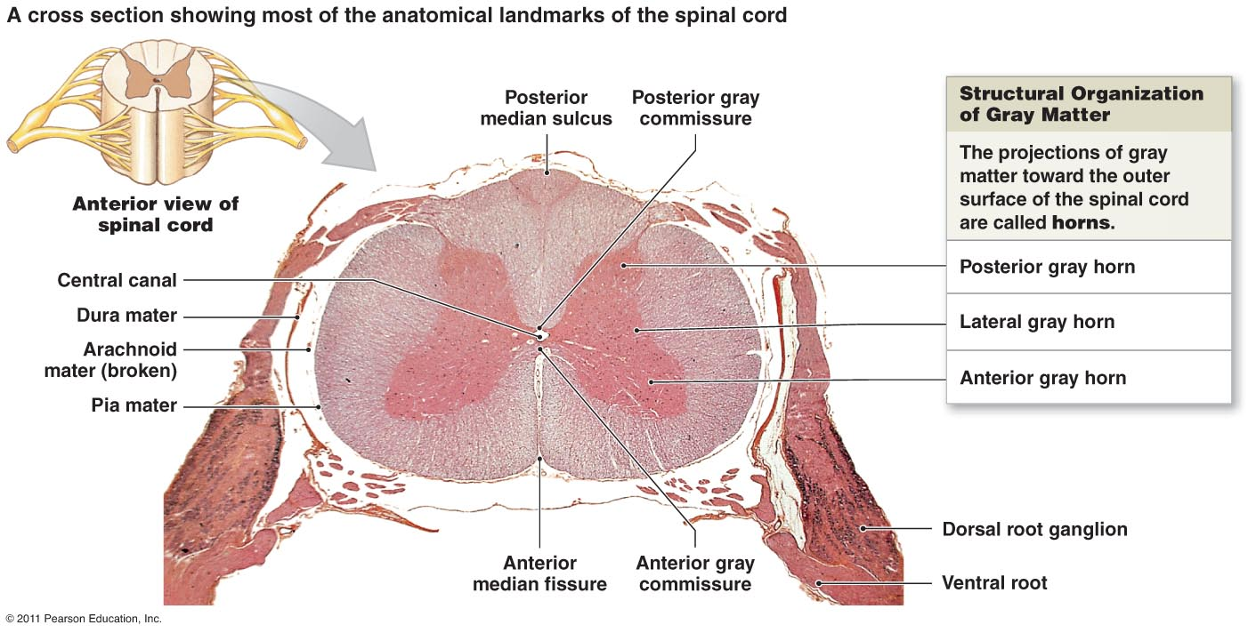](https://www.google.com/url?sa=i&rct=j&q=&esrc=s&source=images&cd=&cad=rja&uact=8&ved=0ahUKEwiS6ff0_dPJAhXJFj4KHTzpAhIQjRwIBw&url=http://www.highlands.edu/academics/divisions/scipe/biology/faculty/harnden/2121/notes/cns.htm&psig=AFQjCNFrJfw86S9o5b4Ez7fsVn-bhxrZjw&ust=1449929330640886)a

b

**Figure 1.** (a) Spinal cord anatomy, (b) 2D model of sagittal section through mid-left gray horn.

For this problem, we are going to do a simulation of the growth of an astrocytoma (Figure 1b). To do this we are going to use the classic ***nonlinear*** PDE shown in equation (1) **which consists of a standard diffusion equation (LHS and 1st term on RHS)** and the logistic growth model (2nd term on RHS) where *C* is the concentration of tumor cells.

$\frac{∂C}{∂t}=∇∙\left(D∇C\right)+k\left(C-C^{2}\right)$ (1)

1. We are going to also simulate the **anisotropic** nature of nerve tissue in this simulation. First begin by writing the finite difference equation expressions for: (1) a node that is in the white matter, and (2) a node that is in the gray matter for the standard *diffusion equation only*, *i.e., for this part of the assignment, we will neglect the nonlinear 2nd term on the RHS*. For this exercise we are going to assume a ***fully explicit*** formulation. Also, recall that in this case the 2nd order tensor that represents diffusion for the white matter only is symmetric, i.e., $D=\left[\begin{matrix}D_{xx} & D_{xy} \\ D_{xy} & D_{yy}\end{matrix}\right].$ Also, you will notice in Figure 1b, that the fibers associated with white matter (yellow part) are perfectly aligned with the conventional Cartesian coordinate, x-axis. Cross-fiber diffusion would be in the direction **of the y-axis (as a result $D_{xy}=0$).** In writing (1) and (2) described above, write out the finite difference equation with the respective properties designated properly. You do NOT need to form a molecule, i.e., you can write out in algebraic equation form. Of course, if that representation helps you, you can but be sure it represents a distinct equation.
2. Next, let’s program it up. For this part of the problem, you will be engaging the full equation (1), ***all terms in equation (1)***. One of the advantages of **a fully explicit model** is that terms like the 2nd term on the right--hand side can be handled quite directly as they are based on the known history of the concentration. The **boundary conditions** are shown in Figure 1b. The values for the diffusion coefficients are shown, ***DGM, DWMLong*. and *DWMTrans****.* which are the diffusion coefficients for gray matter (typically considered isotropic), white matter along fiber directions, white matter transverse to fiber directions (i.e., across fibers), respectively. Note the yellow regions in Figure 1b are the white matter (typically considered anisotropic) and all fibers are aligned with the x-axis. The grid spacing, and geometric arrangement of the gray and white matter is *x=y=0.05*. The full dimensions of the nerve segment are shown in Figure 1b. Grid coordinates and discretization should be kept in centimeters. No unit conversions are necessary if this is the case. You should use a time step of *t=0.0005* days and run the model out to a final time of *100 days*. Also, the proliferation rate for this problem is *k=0.15.* For this problem, you are going to execute 3 scenarios.

**Scenario 1.** Along the centerline of the tissue at a depth of l =0.6cm, tumor growth (P in Figure 1b) has initiated at time t=0 with an initial tumor cell concentration of C=0.01, i.e., *C(xl, yl, t=0)=0.01*. Using this ***initial condition***, simulate the tumor growth.

**Scenario 2.** Along the centerline of the tissue at a depth of l =0.4cm, tumor growth (P in Figure 1b) has initiated at time t=0 with an initial tumor cell concentration of C=0.01, i.e., *C(xl, yl, t=0)=0.01*. Using this ***initial condition***, simulate the tumor growth.

**Scenario 3.** Along the centerline of the tissue at a depth of l =0.2cm, tumor growth (P in Figure 1b) has initiated at time t=0 with an initial tumor cell concentration of C=0.01, i.e., *C(xl, yl, t=0)=0.01*. Using this ***initial condition***, simulate the tumor growth.

In this part with ***each scenario***, provide a spatial distribution of the tumor at time t=10, 50, 100 days. The command ‘imagesc(MatrixVariable)’ can be a useful command. It is important to use the command

*>> axis equal* , *>> colorbar* with each to make sure proper scale as well as my ability to evaluate your cell distribution quantitatively.

1. As this is a 2D calculation, determine the tissue area in cm2 that contains tumor cells. For this problem, assume that a cell is positive for tumor if the concentration of tumor cells is C > 0.01. To assist, a useful command in MATLAB is the ‘find’ command. For example, if A=[1 2 3;4 5 6;7 8 9] and if I type [a,b]=find(A>5), this will return a=[3;3;2;3] and b=[1;2;3;3]. The ‘a’ variable is the row, and the ‘b’ variable is the respective column for every value in A > 5.

**Report Metric #1**: Please report this in the form of a table that lists the ***tissue area values*** comprised of positive tumor presence. Also list as a separate column as a percentage of the total tissue area? Use the following table structure.

|  |  |  |
| --- | --- | --- |
| **Location of Tumor (cm)** | **Area (cm2)** | **% of total area** |
| 0.2 |  |  |
| 0.4 |  |  |
| 0.6 |  |  |

**Report Metric #2:** In addition, interpret the findings with respect to your understanding of diffusion and the impact of tumor initiation relative to location?

1. With the simulations from the part (b) ***scenarios***, I would like you to extract the value of cell concentration at the seed point over the entire time course of your simulation and make a plot with *Cell Concentration at Seed Point* on Y-axis, and *Time* on the X-axis. Overlay the results of these three scenarios. Please explain your findings with respect to tumor growth biology dynamics? More specifically, I can read a plot – what does the plot indicate about tumor growth and the tissue it grows in? Why do you think the dynamic you are seeing is shaped the way it is? In the case that a therapeutic is administered, is there anything about tumor initiation that is important? Lastly, if you were to administer a therapeutic and wanted to model its impact on tumor growth, how would you alter equation (1)?